**Student Performance**

**Saif Attieh**

Table Of Contents

**Overview 3**

**First five rows 3**

**Data description 3**

**Data information 4**

**Distribution of Extracurricular Activities 4**

**Performance index & Hours Studied 5**

**Average performance index with extracurricular activities 6**

**Heat map chart 7**

**Average performance index & Sleep Hours 7**

**Sample Question papers practiced & Average performance index 8**

**Sample Question Papers Practiced & Average Previous Scores 9**

**Maximum & minimum previous scores 10**

**Regression Table 11**

**t: is the "t-value" of the coefficients. 11**

**Regression: Performance index vs previous scores 12**

**Regression: Performance index vs Sleep Hours 13**

**Regression: Performance index vs Sample Question Papers Practiced 14**

**References 14**

## **Overview**

This dateset provides an insightful look into factors influencing student performance across various academic and extracurricular domains. It encompasses several key attributes that help in understanding how different variables correlate with academic achievement.

## [First five rows](#_First five rows)

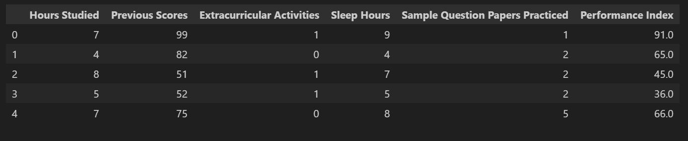

## [Data description](#_Data description)

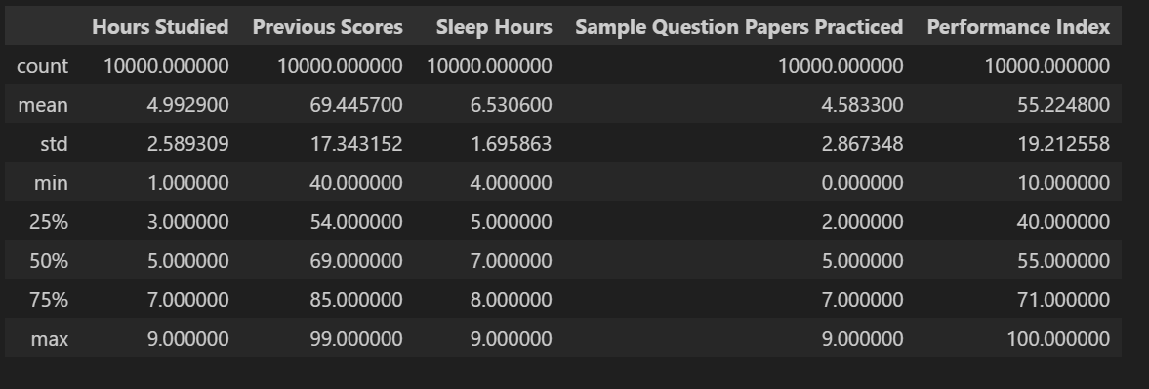

## Data information

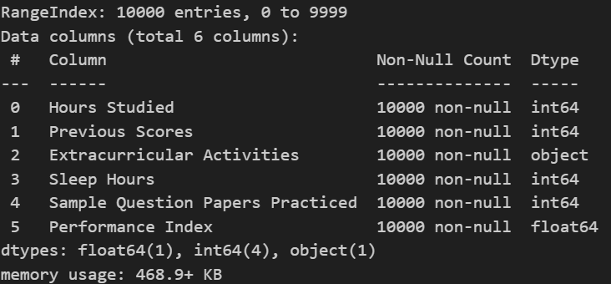

## Distribution of Extracurricular Activities

This figure is a bar chart displaying the count of students based on their participation in extracurricular activities. Also, The chart indicates a visual comparison of the number of students in each category. It seems like the counts for both categories are similar, with slightly more students participating in extracurricular activities than those who do not.

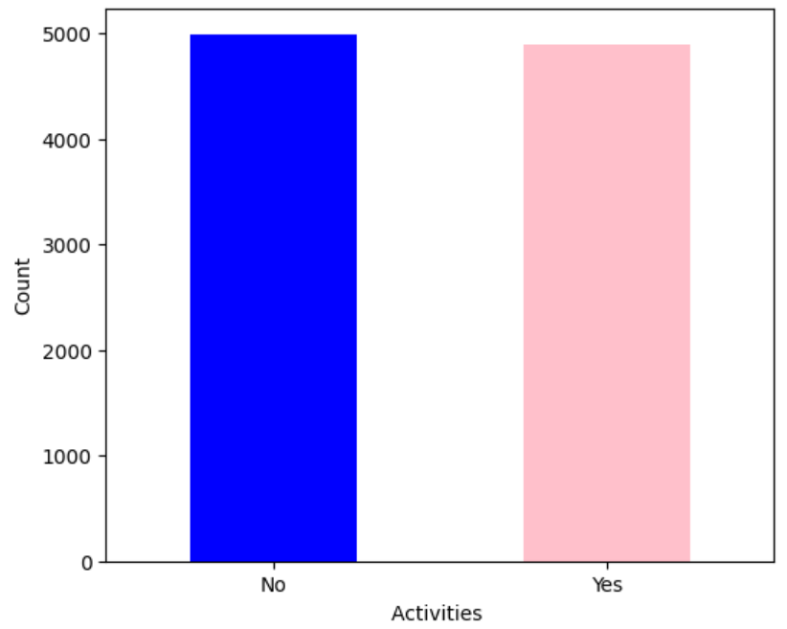

## **Performance index & Hours Studied**

This Chart it can be observed that as the number of hours studied increases, the performance index generally tends to increase as well.

This suggests a positive correlation between the amount of time spent studying and student performance.

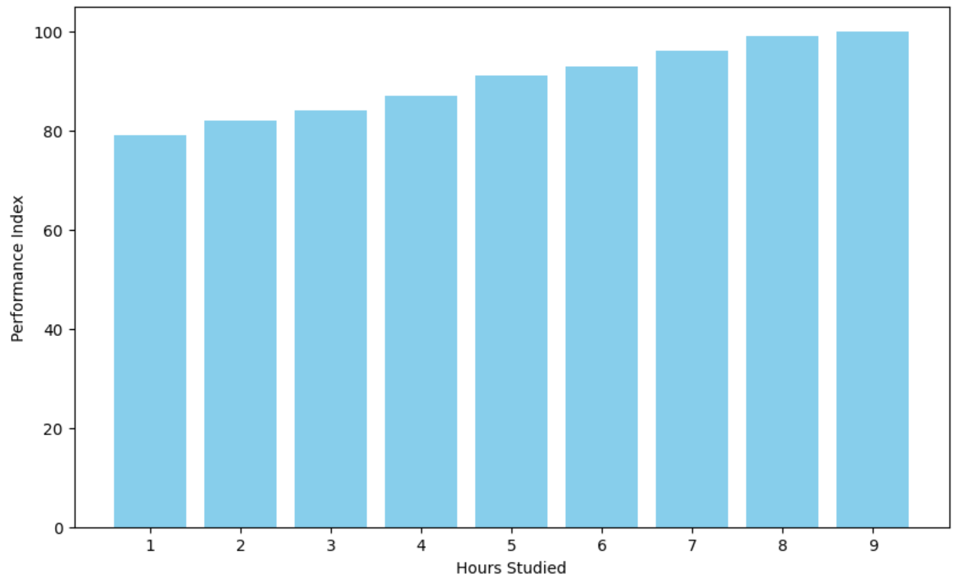

## Average performance index with extracurricular activities

This figure explain average performance index with extracurricular activities and 55.70 they make extracurricular activities and 54.76 they not.

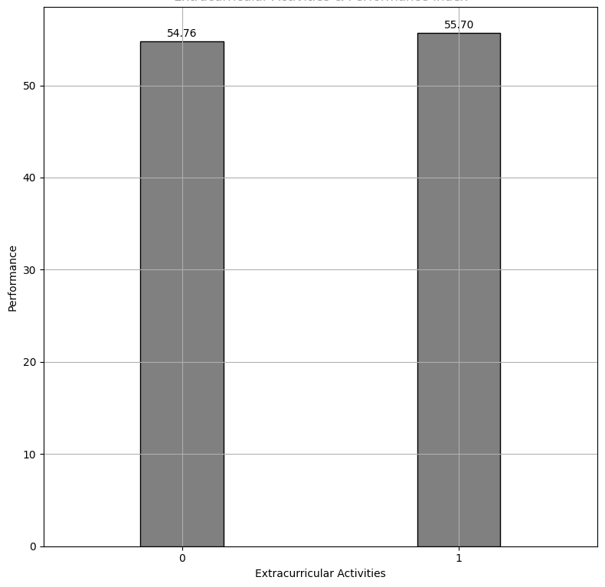

## Heat map chart

The closer the correlation coefficient is to 1, the bluer the squares get.

The closer the correlation coefficient is to -1, the whiter the squares get.

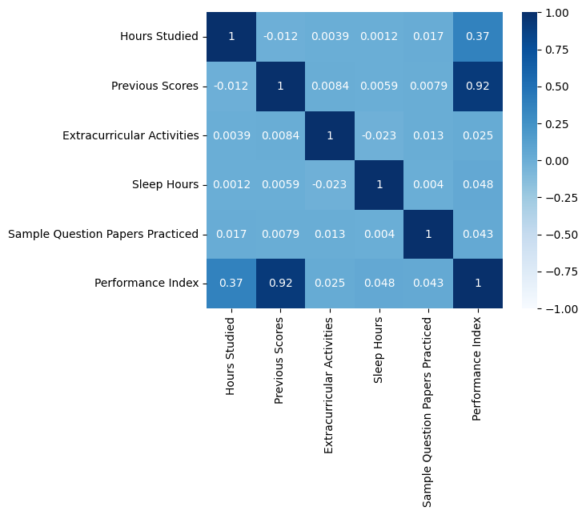

## Average performance index & Sleep Hours

The fewer hours of sleep, the less average performance index and vice versa

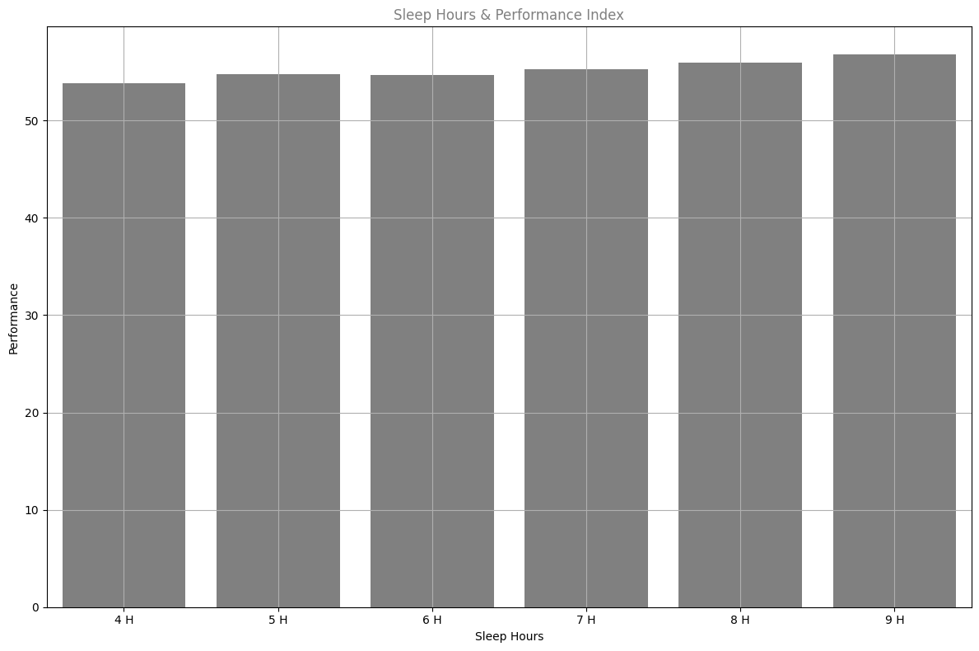

## Sample Question papers practiced & Average performance index

This bar graph displays the relationship between the number of sample question papers practiced and the average performance index. Also, it suggests that the students who engage in more practice with sample papers tend to achieve better performance indices.

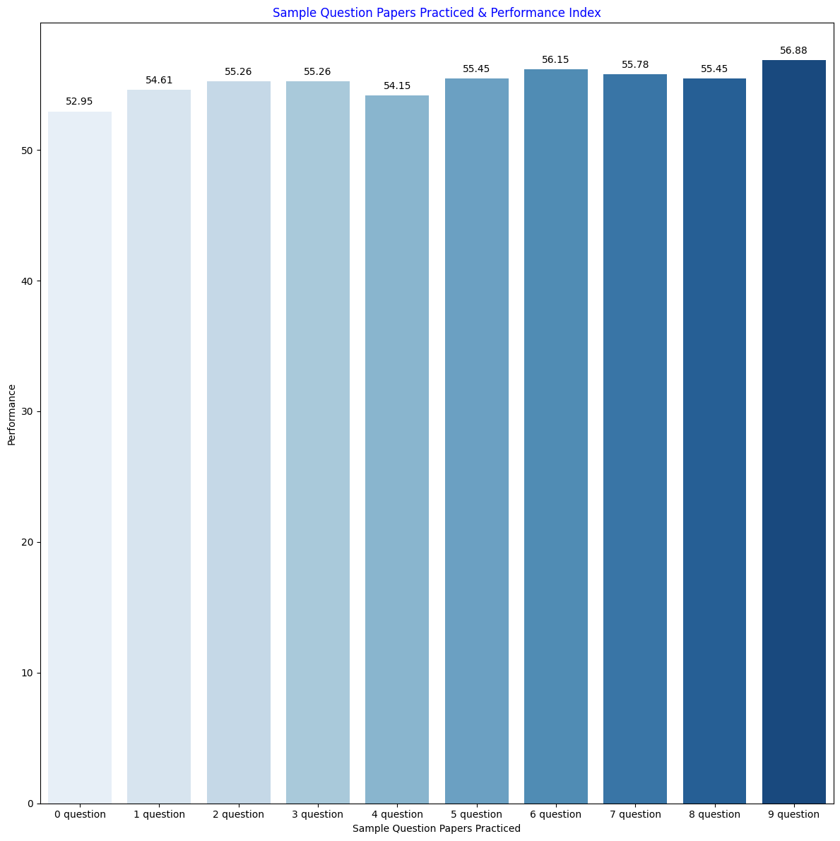

## Sample Question Papers Practiced & Average Previous Scores

This bar graph illustrate the relationship between Sample Question Papers Practiced & Average Previous Scores. Also, the graph suggests that practicing sample question papers is associated with slight improvements in previous scores, possibly indicating better preparation and understanding of the subject matter.

## sample & previousMaximum & minimum previous scores

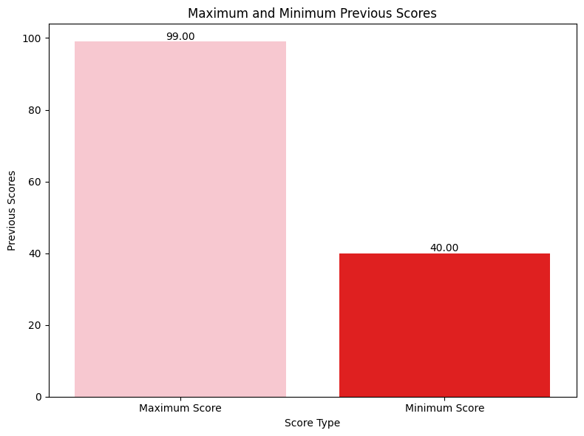

## Regression Table

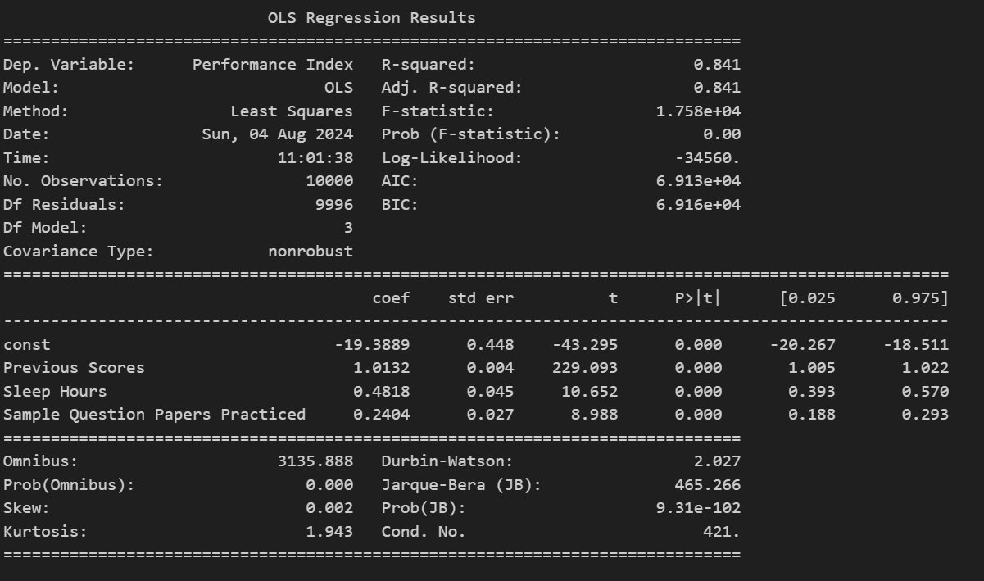

****Dep. Variable:**** is short for "Dependent Variable". Performance Index is here the dependent variable. The Dependent variable is here assumed to be explained by previous scores, sleep hours and Sample question papers practiced.

****Model:**** OLS is short for Ordinary Least Squares. This is a type of model that uses the Least Square method.

****Date:**** and ****Time:**** shows the date and time the output was calculated in Python.

****Coef:**** is short for coefficient. It is the output of the linear regression function

****std err:**** stands for Standard Error.

**t**: is the "t-value" of the coefficients.

****P>|t|:**** is called the "P-value".

The value of **R-Squared** is always between 0 to 1 (0% to 100%).

A high R-Squared value means that many data points are close to the linear regression function line.

A low R-Squared value means that the linear regression function line does not fit the data well.

## Regression: Performance index vs previous scores

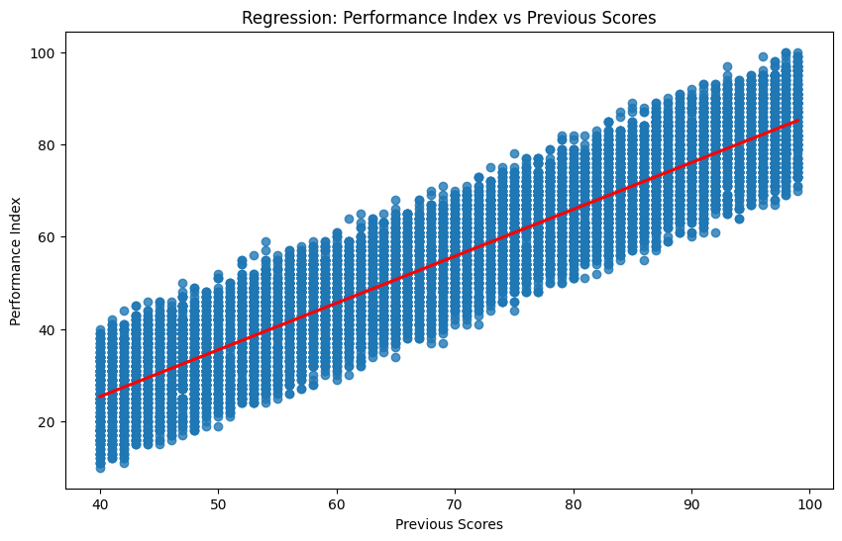

This figure is a scatter plot illustrating the relationship between "Previous Scores" (on the x-axis) and "Performance Index" (on the y-axis). The plot includes a linear regression line (red) that demonstrates a positive correlation, suggesting that higher previous scores are associated with higher performance index values. However, the spread of data points around the regression line indicates some variability, implying that the linear model may not fit the data perfectly.

## Regression: Performance index vs Sleep Hours

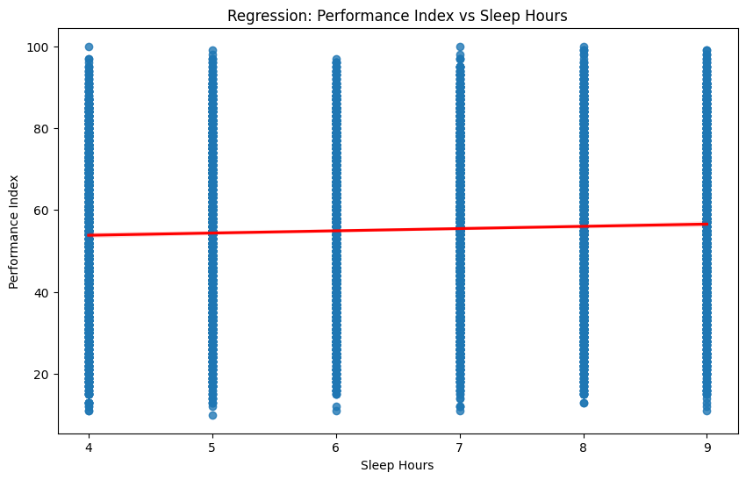

This graph is a scatter plot showing the relationship between "Sleep Hours" (x-axis) and "Performance Index" (y-axis). The linear regression line (red) indicates that there is little to no correlation between sleep hours and performance index, as the line is almost horizontal and the data points are widely dispersed around it.

## Regression: Performance index vs Sample Question Papers Practiced

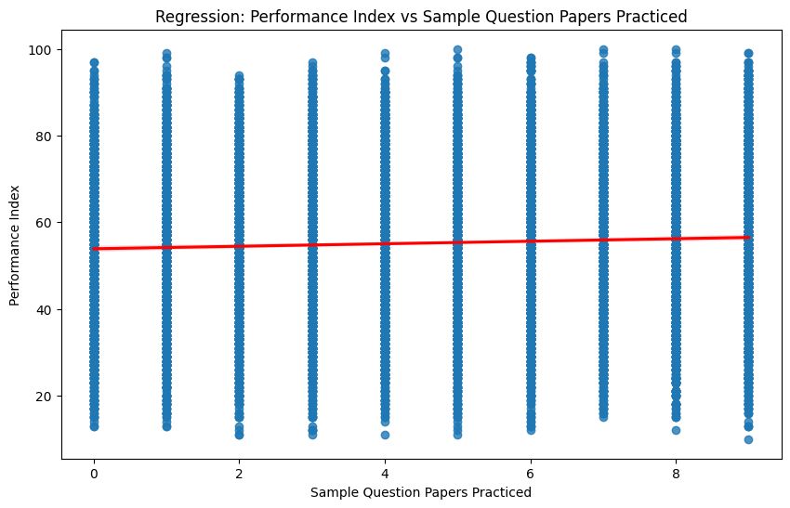

This graph is a scatter plot depicting the relationship between "Sample Question Papers Practiced" (x-axis) and "Performance Index" (y-axis). The linear regression line (red) is nearly flat, suggesting that there is minimal or no significant correlation between the number of sample question papers practiced and the performance index. The data points are widely scattered, indicating high variability in the performance index regardless of the number of papers practiced.

## References

W3Schools and ChatGPT